**SLF4J Demonstration**

* SLF4J stands for Simple Logging Facade for Java.
* It allows you to write logging code that works with different logging frameworks (like Logback, Log4j, etc.) without changing your code.
* Think of it as a universal logging interface.

**Exercise 1**

Java application using SLF4J with Logback to demonstrate logging of error messages and warning levels.

**Output**

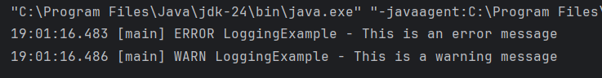

**Exersice 2**

A Java application that demonstrates parameterized logging using SLF4J.

**Output**

